Nyack Boat Club
2019 Wednesday Night Sailing Instructions
04/21/2019

RULES
The series will be governed by the rules as defined in The Racing Rules of Sailing.

NOTICE TO COMPETITORS
Notices to competitors will be posted on the Race Committee Notice Board located at the south end of the NBC porch.

CHANGES TO SAILING INSTRUCTIONS
Any change to the sailing instructions will be posted at least 2 hours prior to the affected event(s), or announced on the water on VHF by the Race Committee (RC).

SIGNALS MADE ASHORE
  - Signals made ashore will be displayed from the flagpole at the RC slip.
  - When flag AP is displayed ashore, ‘1 minute’ is replaced with ‘not less than 20 minutes’ in the race signal AP.

SCHEDULE OF RACES
The racing schedule is published in the 2018 NBC Wednesday Night Notice of Race.

CLASS FLAGS
  - The class flags will be the Code Flag #1 for the Spinnaker Fleet, and the Code Flag #2 for the Non-Spinnaker Fleet.
  - If both fleets start together, the start flag will be the Code Flag #3.
  - The Open Fleet flag will display the emblem “O”.
  - Boats shall display division streamers on their backstay:
Start | Division | Streamer | Class Flag
1 | Spinnaker | Orange | Code Flag #1
2 | Non-Spinnaker | Green | Code Flag #2
3 | Open | None | “O”

RACING AREA
The racing area will be the part of the Hudson River known as the Tappan Zee, south of Hook Mountain and north of the Tappan Zee Bridge.

COURSES
  - The courses are listed on the last page of these SI’s.
  - No later than the warning signal, the RC will display the course on the stern of the Signal Boat, and announce the course and division about to start on VHF.

MARKS
  - Marks will be NBC seasonal white cylinders with orange letters or numbered government navigation buoys.
  - The starting and/or finishing marks will be orange inflatable tetrahedrons.
  - Change of course marks, as provided in instruction 12, will be one of the marks described in 9.1.
  - Open Division marks will be orange inflatable tetrahedrons.

OBSTRUCTIONS
  - The NBC mooring area and the restricted construction zone are designated as obstructions. No boat shall sail within these obstructions while racing. The mooring area is defined as the area within straight lines joining all outermost mooring buoys. The construction area is defined in the USCG Notice to Mariners. The boundaries are marked with large white round buoys.
  - A boat that is racing shall not cross the start and/or finishing line(s) except when preparing to start, starting, or finishing. Except at those times, the start and/or finishing line(s), including the marks bounding them, are designated as a single obstruction.

THE START
  - The starting line will be between the hoist displaying an orange flag on the signal boat at the starboard end and the course side of the starting mark.
  - A boat starting later than 10 minutes after her starting signal will be scored DNS without a hearing. This changes RRS 63.1, A4, and A5.
  - Boats whose warning signal has not been made shall keep clear of the starting area during the starting sequence for other races.
  - The RC will attempt to hail the sail number(s) for OCS boat(s) on VHF after the starting signal. Failure to make a hail or to time it accurately will not be grounds for a request for redress. This changes RRS 62.1(a).

CHANGING THE NEXT LEG OF THE COURSE
Changes of course will be announced on VHF. There will be separate announcements for each fleet. This changes RRS 33.

THE FINISH
The finish line will be between the hoist displaying an orange flag on the signal boat and the course side of the nearby finishing mark.

PENALTY SYSTEM
Appendix T Section A: Penalties While Racing, Section B: Post Race Penalties, Section D: Arbitration, and T3: Informing the Race Committee, will be in effect.

TIME LIMITS
  - The time limit for a race shall be two hours from its starting signal. If no boat in that fleet completes the race within the two-hour limit, the race shall be abandoned.
  - Any boat that has not finished within 45 minutes of the first finisher in her fleet, or the two-hour time limit, whichever is longer, shall be scored TLE without a hearing. This changes rules 35, 63.1, A4 and A5.

PROTESTS AND REQUESTS FOR REDRESS
  - Protest forms are available in the rack next to the RC locker. Protests and requests for redress shall be delivered to the RC within the time limit.
  - The time limit for protests and requests for redress shall be 1 hour after the RC signal boat reaches her mooring or slip. This includes protests and requests for redress by the RC. This changes RRS 62.2.
  - A boat intending to protest or request redress shall inform the RC per Appendix T3.

SCORING
Each fleet shall determine their series scoring.

SAFETY
  - All cruising boats intending to race shall check in with the RC, while underway, before the race, by hailing the RC on VHF with their sail number and receiving verbal confirmation from the RC. Any boat that has not checked in will be scored DNC. This changes RRS 63.1, A4 and A5.
  - A boat that retires from a race shall notify the RC as soon as possible by sailing by the signal boat or mark boats, or hailing the RC on VHF. 18.3. A boat that retires and does not notify the RC will be scored DNE, Disqualification Not Excludable. This changes RRS 63.1, A4 and A5. 18.4. All boats must have a working VHF radio, and monitor it for announcements from the RC. OCS, abandonment and change of course will be announced by VHF.
18.5. All boats are required to carry the following safety equipment: suitable anchor and rode, hand-bailer or pump, paddle or motor, whistle or horn and a Type IV throwable flotation device. All boats must have a US Coast Guard approved PFD for every person on board. 18.6. The RC may inspect a boat at any time; any boat found deficient shall be disqualified from all races for the day. This changes RRS A4, A5, and 63.1.
  - Starting 30 minutes after official sunset, all boats shall display proper night lighting.
  - Open Division boats shall check in by sailing past the Signal Boat on starboard tack and hailing their sail number.
  - All competitors in the Open Division must wear a US Coast Guard approved PFD from the time they leave the dock until the time they return to the dock.

RADIO COMMUNICATIONS
  - All communications to and from the RC shall be on VHF Channel 78.
  - A boat may use VHF to communicate with the RC under the following circumstances: checking in, retiring from a race, in need of assistance, or medical emergency.
  - Except for the circumstances listed in 19.1, a boat shall neither make radio or cell phone transmissions while racing nor receive radio or cell phone communications not available to all boats.

DISCLAIMER OF LIABILITY
Competitors participate entirely at their own risk. See RRS 4, Decision to Race. The Organizing Authority will not accept any liability for material damage or personal injury or death sustained in conjunction with or prior to, during, or after the race.

INSURANCE
Each participating boat shall be insured with valid third-party liability insurance.

2019 Courses
Wind | Course | Start | Spinnaker | Approx. nm | Non-spinnaker | Approx. nm | Finish
N | 1 | S | A-C | 4.4 | B-D | 2.5 | S
N | 2 | S | B-C-B-C | 6.8 | B-D-C | 3.8 | S
N | 3 | S | B-D-C-B-C | 6.5 | B-D-C-E | 4.7 | S
NE | 4 | S | 11 | 3.3 | B-A | 2.8 | S*
NE | 5 | S | 11-D | 4.3 | 11-D | 4.3 | S
NE | 6 | S | 11-A-D | 4.6 | 11-A-D | 4.6 | S
E | 7 | S | E | 1.4 | E | 1.4 | S*
E | 8 | S | E-D | 2.8 | E-D | 2.8 | S
E | 9 | S | E-D-E-D | 5.5 | E-B-D | 3.6 | S
SE | 10 | S | E-A | 3.8 | E-B | 2.7 | S
SE | 11 | S | E-A-B-A | 5.1 | E-A | 3.8 | S
S | 12 | S | C-A | 4.5 | C-E-B | 3.9 | S
S | 13 | S | C-B-C-B | 6.7 | C-E-A | 5.1 | S
SW | 14 | S | D-11 | 4.4 | D-E-B | 4.1 | S
SW | 15 | S | D-11-D | 5.5 | D-C-B-D | 5.2 | S*
W | 16 | S | D-E | 2.8 | D-E | 2.8 | S
W | 17 | S | D-E-D-E | 5.5 | D-C-E | 3.4 | S
NW | 18
NW | 19 | S | A-C-E | 5.3 | B-C-E | 4.3 | S
NW | 20 | S | A-C-E-B | 5.8 | A-C-B | 6.0 | S*

*downwind finish
All marks shall be left to port, except for downwind finishes, when the finish mark shall be left to starboard.
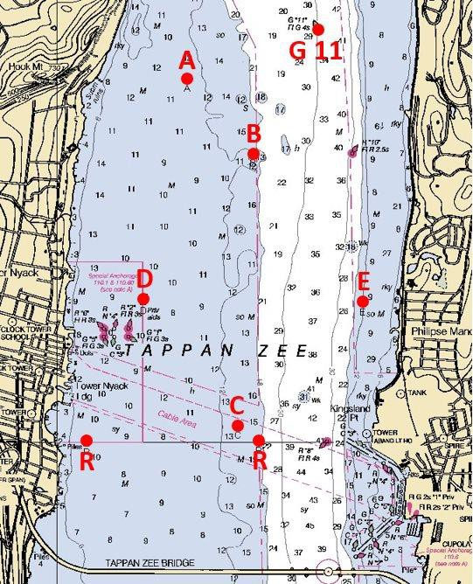
An “X” displayed after the course number on the signal boat indicates that the course shall be sailed to the first mark and then back to finish at the signal boat.

Approximate GPS Coordinates for Marks
A | N 41o 07.238' | Seasonal Marks
A | W 073o 53.937' | Seasonal Marks
B | N 41o 06.779' | Seasonal Marks
B | W 073o 53.401' | Seasonal Marks
C | N 41o 05.099' | Seasonal Marks
C | W 073o 53.527' | Seasonal Marks
D | N 41o 05.866' | Seasonal Marks
D | W 073o 54.297' | Seasonal Marks
E | N 41o 05.857' | Seasonal Marks
E | W 073o 52.506' | Seasonal Marks
11 | N 41o 07.547' | Government Mark
11 | W 073o 52.868' | Government Mark
S | TBD on day of Race | Start Position
R | N 41o 04.995' | USCG exclusion zone
R | W 073o 54.759' | USCG exclusion zone
R | N 41o 05.003' | USCG exclusion zone
R | W073o 53.358' | USCG exclusion zone

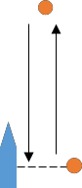
The Open Division start mark shall be left to starboard, and the downwind finish mark left to port.
Open Division Course

