**Shattemuc Yacht Club**

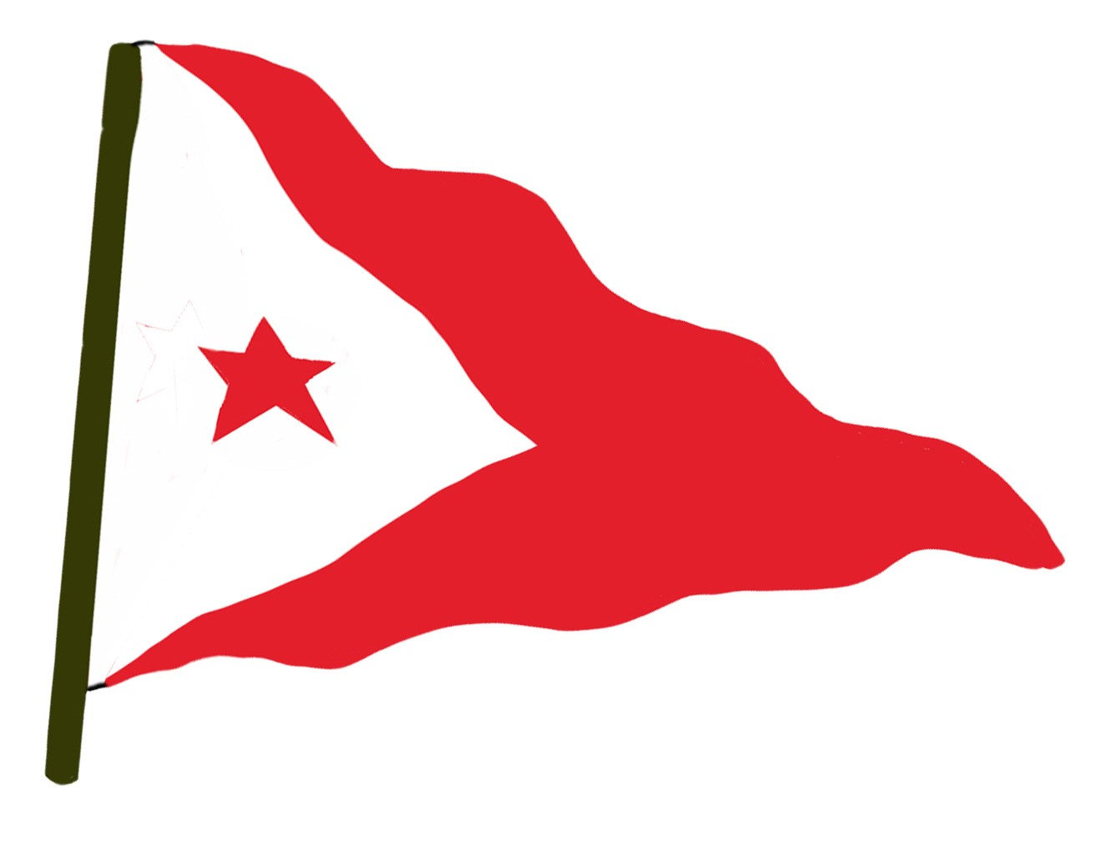

**41st annual PEDLOW CUP Series, 2019**

**NOTICE OF RACE and SAILING INSTRUCTIONS**

**Scheduled Race Dates:**

Memorial Day Race: Sunday, May 26

Independence Day Race: Sunday, July 7

Labor Day Race: Sunday, September 1

1. RULES - The Pedlow Cup races will be governed by the 2017-2020 Racing Rules of Sailing.

2. SCHEDULE –

09:30 AM - skippers’ meeting on the deck of the clubhouse

10:30 AM – first warning signal

There will be a maximum of two races on each day.

3. ANNOUNCEMENTS – Race date and other schedule changes will be posted prior to the day that they take effect on the Shattemuc web site: <http://www.shattemucyc.org/activities/racing#Pedlow>. Other announcements may be made on the water on race days orally and/or by VHF Channel 72 without posting.

4. ENTRY - The SYC Pedlow Cup is open to all members of Shattemuc YC and Nyack BC and guests.

Yachts may pre-register at the skippers’ meeting. Late entrants may register with the committee on the water

prior to the races. Please try to honor the “Pedlow Ideal” when selecting skipper and crew.

5. RACE COURSE – Will be announced on the water on VHF Channel 72 prior to each race.

6. CLASSES – There will be one non-spinnaker class. The CLASS FLAG will be RED.

7. PRIOR TO START – Please sail past the committee boat and register by reporting your sail number and boat name orally.

8. START – The starting line is between an orange flag on the Committee Boat and a white, yellow,

or orange ball float. There will be several short sound signals approximately a minute before the first warning signal and an announcement on VHF Channel 72 to confirm the course and alert boats to the imminent commencement of the 5 minute start sequence. Following this, the start sequence will be as described in RR26:

5 min. before start: WARNING: CLASS flag raised, one sound

4 min. before start: PREPARATORY: code flag “P” (blue flag with white center square) raised, one sound

1 min. before start: code flag “P” lowered, one LONG sound

0 min. before start: CLASS flag lowered, one sound

9. FINISH - The finish line will be set after the start in the vicinity of the start line.

The finish line is between an orange flag on the Committee Boat and a white, yellow, or orange ball float.

10. Time Limits – If no boat sails the course and finishes a race within 1.5 hours from her start time, the race will be abandoned. Boats failing to finish within 1.0 hours after the first boat sails the course and finishes will be scored Did Not Finish without a hearing. This changes rules 35, A4 and A5.

11. SCORING – Handicapping is by PHRF Time-on-time. A series trophy, the PEDLOW CUP will be awarded to the Shattemuc boat with lowest sum of scores for all completed races in the series. Additionally there will be a series trophy for the non-Shattemuc boat with lowest sum of scores for all completed races in the series. There will be no throw-outs.