Nyack Boat Club
2014 SAILING INSTRUCTIONS – WEDNESDAY NIGHT SERIES

1 RULES
The Wednesday Night Racing Series will be governed by the rules as defined in the current Racing Rules of Sailing.
2 NOTICE TO COMPETITORS
Notices to competitors will be posted on the Race Committee
Notice Board located at the south end of the Boat Club porch.
3 CHANGES TO SAILING INSTRUCTIONS - Any changes to the sailing instructions will be posted at least 1 hour prior to the affected races.
4 SIGNALS MADE ASHORE
4.1 Signals made ashore will be displayed at the RC slip.
4.2 When flag AP is displayed ashore, ‘1 minute’ is replaced with
‘not less than 20 minutes’. This changes Race Signals, AP.
5 SCHEDULE - The racing schedule is in the NOR for the NBC Wednesday Night Series 2014. No warning signal will be made
after 7:30 pm.
6 STARTING DIVISIONS; FLAGS and STREAMERS
There will be starts for 4 Keelboat Divisions, and dinghies as needed. The starting order is indicated below:
Start | Division | Streamer | Class Flag
1 | Spinnaker Div 1 | CodeFlag#1 | CodeFlag#1
2 | Non-Spin Div 2 | CodeFlag#2 | CodeFlag#2
3 | Non-Spin Div 3 | CodeFlag#3 | CodeFlag#3
4 | Fun Fleet | CodeFlag#4 | CodeFlag#4
5 | Dinghies | none | O

6.1 No later than the warning signal, the RC will announce on VHF channel 78 the division about to start and the course; and display the course number on the stern of the signal boat.
6.2 Streamers shall be flown from the backstay of each competing boat, approximately 6’ above deck level.
6.3 Dinghies will start together as one division, unless a class
has six or more starters, in which case it will be given a separate start at the discretion of the PRO.
7 RACING AREA
7.1 The racing area will be that part of the Hudson River known as the Tappan Zee south of Hook Mountain and north of the
Tappan Zee Bridge.
7.2 The mooring area and restricted construction zone are designated as obstructions. No boat shall sail within these obstructions while racing. The mooring areas are defined as the area within straight lines joining all outermost mooring buoys and the restricted construction zone is between the “R”’s and the bridge in the course map. “R”’s maybe subject to change by construction. The penalty for sailing within these obstructions while racing shall be disqualification from that race. This changes RRS A5.
8 COURSES and MARKS
8.1 The Course Diagram and the identifying course numbers are illustrated on the last page of these Sailing Instructions. An X
after the course number indicates that the course shall be
sailed to the first mark then finish back at the signal boat.. RC
also will announce this change on VHF channel 78.
8.2 Marks for the Keelboat divisions will be orange inflatable marks, NBC Seasonal marks (white cylinders, lettered) and/or government navigation buoys (numbered). Marks for the Dinghy fleet will be red inflatable balls, orange inflatable
marks and/or NBC Seasonal marks. Change marks will be yellow inflatable.
8.3 Change marks as provided in instruction 11 will be yellow inflatable marks described in instruction 8.2.
8.4 A boat that is racing shall not cross the Start or Finish line(s)
except when preparing to start, starting, or finishing. The RC, without a hearing, shall score ‘DSQ’ to a boat that crosses the line(s). This changes RRS A5 and 63.1.
9 THE START
9.1 The starting line will be between the mast displaying an orange flag on the signal boat and a nearby mark.
9.2 If the individual recall flag is displayed, the Race Committee
will attempt to broadcast the sail number(s) for the OCS
boat(s) on VHF Channel 78. Failure to make a broadcast or to time it accurately will not be grounds for a request for redress.
This changes RRS 62.1(a).
10 THE FINISH
The finishing line will be between the mast displaying an orange flag on the signal boat and a nearby mark.
11 CHANGING THE NEXT LEG OF THE COURSE
Changes of course will be announced on Channel 78. There will be separate announcements for the Spinnaker and Non- Spinnaker fleets. This changes RRS 33.
12 TIME LIMIT
The time limit for a Wednesday Night race shall be 2 hours from a Division’s starting signal. If no boat in the division completes the race within the 2 hour limit, the race shall be abandoned. If any boat of the division completes the race within the 2 hour time limit, all other boats have 30 minutes from the time of the first finisher to complete the course, or the 2 hour time limit, whichever is longer.
Failure to complete the course within these time limits will be scored
DNF. This changes RRS 35 and A5.
13 PROTESTS
13.1 A boat is required to inform the RC signal boat immediately after finishing of its intention to protest another boat, and provide the sail number of the protested boat. This changes RRS 61.
13.2 Protests and requests for redress shall be made on the NBC Web site, Wednesday Night Protest Form, no later than 11:59 p.m. on the following day of the race. Further instructions will be found on the online protest form. Protests will be heard prior to the start of racing on the following Wednesday Night. This changes RRS 62.2
14 SCORING
Each fleet will determine the series scoring and penalty system.
15 SAFETY
15.1 All boats intending to race, while underway, shall check in with the RC before the first race. Keelboats must hail the RC
on VHF Channel 78, provide sail number and boat name. A
Keelboat is not considered checked in until she receives verbal acknowledgement from the RC. Dinghies must sail past the RC on starboard tack, hailing their sail number and receiving
verbal acknowledgement from the RC.
15.2 A boat that retires from a race must notify the race committee as soon as possible. The penalty for infringing this rule shall be a DSQ in the race closest in time. This changes RRS A5
15.3 Any boat sailing without proper night lighting and everyone on board not wearing PFD’s 30 minutes after official sunset will be disqualified immediately by the Race Committee without a hearing. This changes RRS 63.1, A4 and A5.
15.4 All boats are required to carry the following safety equipment: suitable anchor and rode, pump, paddle or motor, whistle or horn and a Type IV throwable flotation device. All boats must have a US Coast Guard approved PFD for every person on board.
16 DISCLAIMER OF LIABILITY
Competitors participate entirely at their own risk. See rule 4, Decision to Race. The Organizing Authority will not accept any liability for material damage or personal injury or death sustained in conjunction with or prior to, during, or after the race.
17 INSURANCE
Each participating boat shall be insured with valid third- party liability insurance.

Wind | Course | Rounding | Start | Spinnaker | Approx. nm | Non-spinnaker | Approx. nm | Finish
N | 1 | PORT | S | A-C | 4.4 | B-D | 2.5 | S
N | 2 | PORT | S | B-C-B-C | 6.8 | B-D-C | 3.8 | S
N | 3 | PORT | S | B-D-C-B-C | 6.5 | B-D-C-E | 4.7 | S
NE | 4 | PORT | S | 11 | 3.3 | B-A | 2.8 | S*
NE | 5 | PORT | S | 11-D | 4.3 | 11-D | 4.3 | S
NE | 6 | PORT | S | 11-A-D | 4.6 | 11-A-D | 4.6 | S
E | 7 | PORT | S | E | 1.4 | E | 1.4 | S*
E | 8 | PORT | S | E-D | 2.8 | E-D | 2.8 | S
E | 9 | PORT | S | E-D-E-D | 5.5 | E-B-D | 3.6 | S
SE | 10 | PORT | S | E-A | 3.8 | E-B | 2.7 | S
SE | 11 | PORT | S | E-A-B-A | 5.1 | E-A | 3.8 | S
S | 12 | PORT | S | C-A | 4.5 | C-E-B | 3.9 | S
S | 13 | PORT | S | C-B-C-B | 6.7 | C-E-A | 5.1 | S
SW | 14 | PORT | S | D-11 | 4.4 | D-E-B | 4.1 | S
SW | 15 | PORT | S | D-11-D | 5.5 | D-C-B-D | 5.2 | S*
W | 16 | PORT | S | D-E | 2.8 | D-E | 2.8 | S
W | 17 | PORT | S | D-E-D-E | 5.5 | D-C-E | 3.4 | S
NW | 18 | PORT | S | A-E | 3.8 | B-E | 2.6 | S
NW | 19 | PORT | S | A-C-E | 5.3 | B-C-E | 4.3 | S
NW | 20 | PORT | S | A-C-E-B | 5.8 | A-C-B | 6.0 | S*

*downwind finish
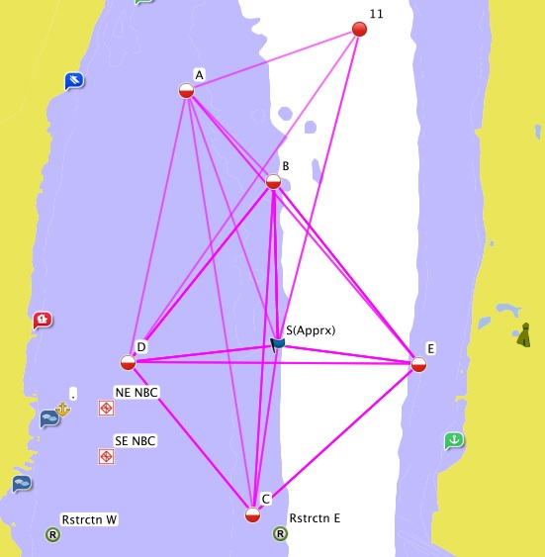

Approximate GPS Coordinates for Marks
A | N 41o 07.238' | Seasonal Marks
 | W 073o 53.937' | Seasonal Marks
B | N 41o 06.779' | Seasonal Marks
 | W 073o 53.415' | Seasonal Marks
C | N 41o 05.160' | Seasonal Marks
 | W 073o 53.527' | Seasonal Marks
D | N 41o 05.866' | Seasonal Marks
 | W 073o 54.297' | Seasonal Marks
E | N 41o 05.857'
 | W 073o 52.506'
11 | N 41o 07.547' | Government Marks
 | W 073o 52.868'
S | TBD on the day of Race | Start Position

One-Design Course Diagram